February 05, 2014 AEE Western Pa Local Chapter

Enerlogics/Clearesults Program – ACT 129 Overview

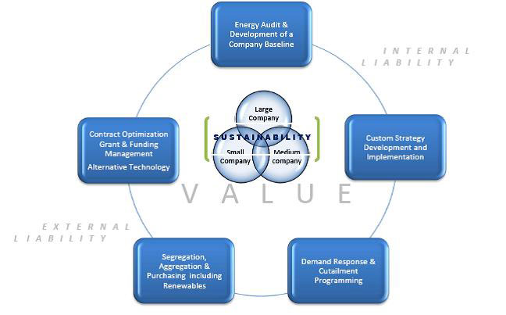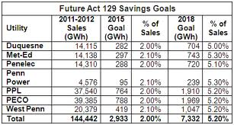
AEE - Western, PA Chapter is pleased to bring you an exciting event that will cover rebates and incentives associated with Pennsylvania ACT 129. Please utilize the web links below to familiarize yourself with both Enerlogics and Clearesult programs.
Location: Gaetano's Banquet Center & Catering
Date: February 27th, 2014
Time: 11:30AM – 1:00PM

Presenters:
Andrew Stroh – Clearesults – Covering FirstEnergy’s Pennsylvania utilities (Met Ed, Penelec, Penn Power and West Penn Power) ACT129
John Choma – Enerlogics – Covering Duquesne Light ACT129

Act 129
http://www.puc.pa.gov/filing_resources/issues_laws_regulations/act_129_information.aspx
http://www.puc.pa.gov/filing_resources/issues_laws_regulations/act_129_information/technical_reference_manual.aspx
http://www.puc.state.pa.us/General/consumer_ed/pdf/EEC_Home-FS.pdf
Clearesult
http://www.clearesult.com/
http://www.energysavepa-business.com/index.php
Enerlogics
http://enerlogics.com/
https://www.duquesnelight.com/WattChoices/Act129.cfm
https://www.duquesnelight.com/WattChoices/Business/LargeOfficeProgram.cfm

